Overall Project:

Low-cost ventilator that can split among at least two patients and provide automatic feedback to the PIP/PEEP valves to alter pressure depending on the patient's needs. Doctor calibrates the appropriate pressure needed for the patient, from there the system should automatically regulate the valves for each patient to minimize intervention by doctors/nurses.

Goal: Find a way to measure PIP and PEEP to provide feedback to the ventilator to alter pressure.

PIP: Peak inspiratory pressure is the highest level of pressure applied to the lungs during inhalation

PEEP: pressure in the lungs above atmospheric pressure that exists at the end of expiration.

Pressure sensors we had in mind:

* BMP 180 (Barometric)
* Differential pressure sensor with a tube connector

Questions:

**1. General**: how can we measure pressure in a ventilator tube using a barometric pressure sensor? What’s the best way to measure pressure in this situation? What kind of pressure sensor should we use?

2. Can we use a pitot tube to do this? If so, how do we measure static and dynamic pressure?

3. Would such a design cause issues with turbulence of the air flow? Does the turbulence of air matter for ventilators?

4. Would looking into flow sensors (calculating for pressure using Poiseuille’s Law) be a viable option for finding pressure? (or would that be more difficult)

5. How often should pressure be measured?

**6. What is the minimum resolution that our pressure sensor should have?**

Look at the peek to peek pressure difference - what’s the min change we need to detect.

7. Could our pressure valve design be tested in Ansys (or some other simulation software)? (I know Dr. Elbert said that would be extraneous, but I’m just wondering Dr. Dan’s opinion regarding how to test whether our pressure sensor/valve would work properly)

Flow isn’t that important here - difficulty with showing pliability of lungs (hard to model)

Notes:

Dynamic pressure - due to flowing air; we won’t have any in our system

We are concerned with static pressure aka total pressure

We only need an absolute pressure sensor measurement

Air flow - negligible

Issue: filters and backflow may affect the pressure if placed in front of sensor

* Set-up: make a T and place [sensor] in T
* Consider measuring pressure on different ends of tube to measure pressure drop (small differences due to friction)
* Water tube to measure correct pressure reading (to isolate pressure from air)

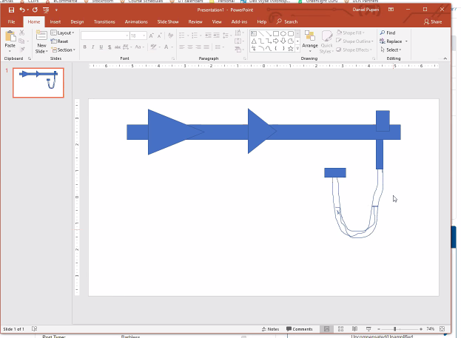

Air chamber + flexible membrane - figure out a way to isolate pressure sensor from the patient’s breath

Look at a time scale for frequency of measurement - 10 hz at least?? Depends on what we want to capture (do we only want to capture max/min?) apply the Nyquist

Difficulties: pliability of the lungs

Flow won’t be too important, pressure is most important

***Physiologically: What is the minimum change in pressure we are looking for?***

